

Tride

by

 GURUPRASAD N 194110

JOGITH BIJU CHUNGATH 1941111

RAGHAV SHAM KAMAT 1941129

SWAROOP P 1941138

Under the guidance of

Dr UMME SALMA M

Specialisation Project report submitted in partial fulfilment of the requirements of V semester BCA, CHRIST (Deemed to be University)

December - 2021



CERTIFICATE

*This is to certify that the report titled* ***Tride*** *is a bonafide record of work done by* ***Guruprasad N(1941110), Jogith Biju Chungath (1941111), Raghav Sham Kamat (1941129),*** *and* ***Swaroop P (1941138)*** *of CHRIST (Deemed to be University), Bangalore, in partial fulfilment of the requirements of V Semester BCA during the year 2022.*

**Head of the Department Project Guide**

Valued-by:

|  |  | Name | : Dr UMME SALMA M |
| --- | --- | --- | --- |
| 1. | Nismon Rio | Designation | : Assistant Professor |
|  |  | Examination Centre | : CHRIST (Deemed to be University) |
| 2. |  | Date of Exam | : 25/11/2021 |

**ACKNOWLEDGEMENTS**

We would like to express our special thanks of gratitude to Dr Joy Paulose, Head of Department of Computer Science, CHRIST (Deemed to be University), and Prof. Deepthi Das, Coordinator, Department of Computer Sciences, CHRIST (Deemed to be University) who gave us the golden opportunity to do this wonderful project and our guide Dr Ummesalma M also helped us in doing a lot of research and we came to know about so many new things. We are thankful to them. Secondly, we would also like to thank my parents and friends who helped me a lot in finalizing this project within the limited time frame.

Any attempt at any level can’t be satisfactorily completed without the support and guidance of my parents and friends.

We would like to thank our guide who helped us a lot in gathering different information, collecting data and guiding us from time to time in making this project. Despite their busy schedules, they gave me different ideas in making this project unique.

**List of Tables**

| **Table No.** | **Table Name** | **Page No.** |
| --- | --- | --- |
| Tab 5.5.1 | Test case for user | 33 |
| Tab 5.5.2 | Test case for user registration | 34 |
| Tab 5.5.3 | Test Case for Fuel Calculator | 34 |
| Tab 5.5.4 | Test Case for Maps | 35 |
| Tab 5.5.5 | Test Case for Trip Diary | 35 |

**LIST OF FIGURES**

| **Fig. No.** | **Figure Name** | **Page No.** |
| --- | --- | --- |
| Fig 3.1.3 | ER Diagram | 18 |
| Fig 3.3.1 | Data Flow Diagram | 19 |
| Fig 3.5.1 | Flow Chart | 20 |
| Fig 4.1.1 | Home Screen | 21 |
| Fig 4.1.2 | Login | 21 |
| Fig 4.1.3 | New User | 22 |
| Fig 4.1.4 | Signup | 22 |
| Fig 4.1.5 | Forgot Password | 23 |
| Fig 4.1.6 | Contact us | 23 |
| Fig 4.1.7 | Features | 24 |
| Fig 4.1.8 | Footer | 24 |
| Fig 4.1.9 | Navigation Bar | 25 |
| Fig 4.1.10 | Navigation bar options | 25 |
| Fig 4.2.1 | Home Page | 26 |
| Fig 4.2.2 | Feature Page | 26 |
| Fig 4.2.3 | About Us | 27 |
| Fig 4.2.4 | Contact us | 27 |
| Fig 4.2.5 | User Login | 28 |
| Fig 4.2.6 | Signup | 28 |
| Fig 4.2.7 | Reset Password | 29 |
| Fig 4.2.8 | Fuel Calculator | 29 |
| Fig 4.2.9 | Past Entries | 30 |
| Fig 4.2.10 | Map | 30 |

**TABLE OF CONTENTS**

**Acknowledgements iii**

**Abstract iv**

**List of Tables vi**

**List of Figures vii**

1. Introduction 1

1.1 Overview of the system 1

* + 1. System Analysis

2.1 Existing System

2.1.1 Limitations of Existing System

* 1. Proposed System

2.2.1 Benefits of Proposed System

* 1. Functional Requirements
  2. Software and Hardware Requirements
     1. System Design

3.1 Block Diagram

3.2 Database Design

* 1. ER Diagram
  2. Data Flow Diagram

3.5 User Interface Design

* + 1. Implementation

4.1 Source Code

4.2 Screenshots

* + 1. Testing

5.1 Test Strategies

5.2 Test Cases and Reports

* + 1. Conclusion

**References**

1. **INTRODUCTION**

Apps play an important role in our daily life. Anything we want we can get only with one mouse click. Speed, reliability and accuracy of the app make it a powerful tool for different purposes. A very important and basic need of today’s modern business world is the quick availability and processing of information using apps. One can easily get the type of required information within a fraction of a second. The project that we have taken is also in this category which is used in our daily life whenever we want to plan a trip at the comfort of our house.

**Objective:**

Tride is a web app which is aimed not only to determine the destinations within the route but also to provide a wide range of facilities to the riders making their journey smooth.The facilities include a summary of desired destinations,suggested stays,motels,garages and places of emergency like hospitals ,all the above mentioned features would be available as menu options ,These options won't restrict the users with itinerary planning, time management finance planning fuel management ,interaction with forums etc. It would also help the users to explore the rate at which you must travel to arrive at your destination, reasonable plan for travel, and cost associated with the travel.With kilometers being an important factor whilst travelling .A major input(kilometer) taken from the user would also give a scheduled break for people travelling so fuel break wouldn't be a problem as it is one of a major concern.

**PROFILE OF THE PROBLEM**

One must know what the problem is before it can be solved. The basis for the trip riding assistant is to assist the trips and plan it efficiently thereby saving time and fuel. A Trip planning app , helps the user buy any product of their need, that eliminates the need to contact multiple travel agencies and trip planning companies for efficient timing h, before deciding upon a particular trip plan that best suits his needs, requirements and satisfaction. Moreover, most of the work involved in this development process has to be done manually which is very time consuming and cumbersome and also, it reduces the efficiency, accuracy.

To know the facts and understanding of the problem in detail, ***System Analysis*** is carried out. It is the process of studying the processes and procedures, generally referred to as business systems, to see how they can operate and whether improvement is needed.

**2.  SYSTEM ANALYSIS**

The objective of the system analysis activity is to develop structured system specification for the proposed system. The structured system specification should describe what the proposed system would do; independent of the technology, which will be used to implement these requirements. The structured system specification will be used to implement these requirements. The structured system specification will be called the essential model (also known as the logical model).

The essential model may itself consist of multiple models, modelling different aspects of the system. The data flow diagrams may model the data and their relationships and the state transition diagram may model the time-dependent behaviour of the system. The essential model thus consists of the following.

1. Context diagram
2. Levelled data flow diagrams
3. Data dictionary for the flow and stores on the DFDs.
4. Process specification for elementary bubbles

**2.1 EXISTING SYSTEM**

One must know what the problem is before it can be solved. The basis for the trip planning assistant is to buy products online and save time.

A trip planning assistant, who wants to buy any product of their need, has to contact different Shoppers, before deciding upon a particular Product that best suits his needs, requirements, and satisfaction. Moreover, most of the work involved in this development process has to be done manually which is very time-consuming and cumbersome, and also reduces efficiency, accuracy.

To know the facts and understanding of the problem in detail, System Analysis is carried out. It is the process of studying the business processes and procedures, generally referred to as business systems, to see how they can operate and whether improvement is needed.

**2.1.1 LIMITATIONS OF EXISTING SYSTEMS**

Although we have tried to do the best and try to do all the things that are possible in an

trip planning assistant, but still the system contains some of the limitations.

The reason for these limitations is the time constraints. Time is the major problem. We

had to deliver the project in a particular period. That’s why we had to leave

Some of the topics that we wanted to cover.

1. This project does not give information about the places to be visited present within the trip planned by the user.
2. This project contains Fuel Calculator,Forums,Itinerary planner, Time and Route planner.

**2.2 PROPOSED SYSTEM**

One must know what the problem is before it can be solved. The basis for the trip planning assistant is to make the journey a pleasurable one and save timing.

A trip planning assistant, helps users to plan trips more efficiently rather than consulting a travel advisor or trip agency who wants to buy any product of their need, and has to contact different agencies, before deciding upon a particular trip plan that best suits his needs, requirements, and satisfaction. Moreover, most of the work involved in this development process has to be done manually which is very time-consuming and cumbersome, and also reduces efficiency, accuracy.

To know the facts and understanding of the problem in detail, System Analysis is carried out. It is the process of studying the business processes and procedures, generally referred to as business systems, to see how they can operate and whether improvement is needed.

**2.2.1 BENEFITS OF PROPOSED SYSTEM**

1) Immediate retrieval of information

The main objective of the new system is to provide for quick and efficient retrieval of information. Any type of information would be available to the user whenever he requires it. The facility would be provided for online queries to cut down on the response time greatly.

2)Immediate storage of information

In the proposed system, it will be easy to store information at any given time at the correct places. The location of storage would be easily available and the user will face no difficulty.

3) Prompt updating of information

In the proposed system, the information will always remain up to date as the updating will be prompt and without any efforts. This factor will be of great importance in the proposed system as it determines the integrity of the information stored.

4) Fast computation of information

The computation of information will be quite fast in the proposed system. Not only mathematical calculations but also logical comparisons will be quick in the new system.

5) Planned approach toward working

The working in the service centre information system will be well planned and organized. The data will be stored properly in the data store, which will help in the retrieval of information as well as in its storage.

6) Generation of managerial and strategic reports

The new system would provide for regular generation of reports, which would help the user in decision-making work and in controlling the overall working of the organization. The generation of these reports would be possible only if the system is organized such that retrieval of information can be made on conditions.

7) Accuracy

The level of accuracy in the new proposed system would be higher. All operations and computations would be done correctly and this will ensure that whatever information is coming from the centre log–in a user friendly front-end, is accurate.

8) Reliability

The reliability of the proposed system would be high due to the above-stated reasons. The reason for the increased reliability of the system is that now there would be proper storage of information, its maintenance would be well managed and retrieval would be possible in the desired manner.

9) Non Redundant Information

In the new system, utmost care would be taken that no information is repeated, any usage of storage or otherwise. This would assure economic usage of storage or space and consistency in the data stored. This will also help make those changes easily as the change would have to be made only at that very place and nowhere else.

**2.3 USER REQUIREMENT**

| The user requires these features from the proposed system:   1. Quick generation of Trip Routes 2. Quick processing of Places to Visit 3. Quick retrieval of data 4. Quick and correct updating of data. 5. Least storage requirements 6. Secured and controllable data storage 7. Full backups of data 8. Readable, clean, up to date and timely reports |
| --- |

**2.4 FUNCTIONAL REQUIREMENTS**

Proposed Process Logic of each module and Implementation.

| Travel and Ride Function | 1. Function available to the general user 2. Users can access the information about various places to be visited. 3. Users can become a member of the site by registering themselves. 4. Users can als meet co travellers on the way. 5. Selected categories can be explored by the user |
| --- | --- |
| Registered User | 1. Log–in page to log into the application. 2. Itinerary Planner 3. Mileage Calculator 4. Meet Co Travellers 5. Forums 6. Can change his/her password |
| General User | 1. We assume that the user knows English & users need not be computer professionals. 2. Users should be aware of the internet. 3. Users can access information through hyperlinks such as navigation of various pages. |

**2.4.1 CONSTRAINTS**

   Only the administrator will be able to make entries in the database and can modify it.As far as our database is concerned we are taking user id which is auto-incremented and it is used as the primary key referenced in the table to use foreign key Different constraints such as not null, unique is used. Unique and not null is mainly used for username and password so that it would not null,

**BACK END DETAILS**

The back end part of a system is more important because it controls all the internal processes open-source of a system. I have chosen the Oracle database as the back end. Because it is the world's Most Capable relational database and provides more security than others.

**DETAIL DESIGN**

SEARCH

On this website two types of users one is registered and another is unregistered. A registered user has to fill the form and then he/she can avail the various features associated with it but unregistered users can only access the landing page and preliminary features until they did not get the registered user.

**2.4.2 FRONT END DETAILS**

The Front End tool is used to give a Graphical user interface to the system. By this, we can make a system user friendly and more capable. I have chosen PHP as the front end tool. Because it is an Open Source Technology, freely available and more familiar with any type of database.

**ABOUT PHP**

PHP: Hypertext Preprocessor is a widely used, general-purpose [scripting language](http://en.wikipedia.org/wiki/Scripting_language) that was originally designed for [web development](http://en.wikipedia.org/wiki/Web_development) to produce [dynamic web pages](http://en.wikipedia.org/wiki/Dynamic_web_page). For this purpose, PHP code is embedded into the [HTML](http://en.wikipedia.org/wiki/HTML) source document and interpreted by a [web server](http://en.wikipedia.org/wiki/Web_server) with a PHP processor module, which generates the [web page](http://en.wikipedia.org/wiki/Web_page) document. As a general-purpose programming language, PHP code is processed by an interpreter application in [command-line](http://en.wikipedia.org/wiki/Command-line) mode performing desired operating system operations and producing program output on its standard output channel. It may also function as a graphical application. PHP is available as a processor for most modern web servers and as a standalone interpreter on most [operating systems](http://en.wikipedia.org/wiki/Operating_systems) and [computing platforms](http://en.wikipedia.org/wiki/Platform_(computing)).

PHP stores whole numbers in a platform-dependent range. This range is typically that of 32-bit [signed](http://en.wikipedia.org/wiki/Signed_number_representations) [integers](http://en.wikipedia.org/wiki/Integer_(computer_science)). Unsigned integers are converted to signed values in certain situations; this behaviour is different from other programming languages. Integer variables can be assigned using decimal (positive and negative), [octal](http://en.wikipedia.org/wiki/Octal), and [hexadecimal](http://en.wikipedia.org/wiki/Hexadecimal) notations. Point numbers are also stored in a platform-specific range. They can be specified using floating-point notation, or two forms of [scientific notation](http://en.wikipedia.org/wiki/Scientific_notation). PHP has a native [Boolean](http://en.wikipedia.org/wiki/Boolean_datatype) type that is similar to the native Boolean types in [Java](http://en.wikipedia.org/wiki/Java_(programming_language)) and [C++](http://en.wikipedia.org/wiki/C%2B%2B). Using the Boolean type conversion rules, non-zero values are interpreted as true and zero as false, as in [Perl](http://en.wikipedia.org/wiki/Perl) and [C++](http://en.wikipedia.org/wiki/C%2B%2B). The null data type represents a variable that has no value. The only value in the null data type is NULL. Variables of the "resource" type represent references to resources from external sources. These are typically created by functions from a particular extension, and can only be processed by functions from the same extension; examples include file, image, and database resources. Arrays can contain elements of any type that PHP can handle, including resources, objects, and even other arrays. Order is preserved in lists of values and hashes with both keys and values, and the two can be intermingled. PHP also supports [strings](http://en.wikipedia.org/wiki/String_(computing)), which can be used with single quotes, double quotes, or [heredoc syntax](http://en.wikipedia.org/wiki/Heredoc).

**2.5 SOFTWARE AND HARDWARE REQUIREMENTS**

| **HARDWARE REQUIREMENTS** | At Developer Side  Hardware Used   1. Intel core i5 2. 4 GB RAM. 3. O.S. – Windows 10   At System Users side   1. Intel core i3 2. O.S. Windows 10 |
| --- | --- |

| **SOFTWARE REQUIREMENTS** | At Developer Side Software Used  1. XAMPP Server 2. MYSQL Database 3. Notepad 4. MS Paint  At System Users SideSoftware Requirements  1. Browser (IE 7.0 or above, Mozilla Firefox, Google Chrome 2. Browser Must be JavaScript Enabled |
| --- | --- |

**2.5 BENEFITS OF USING PHP**

PHP is one of the most popular server-side scripting languages running today. It is used for creating dynamic WebPages that interact with the user offering customized information. PHP offers many advantages; it is fast, stable, secure, easy to use, and open-source consists (free).

1. User friendly
2. GUI
3. Separation of work (designing  &coding)
4. Written once run anywhere
5. PHP API

**ADVANTAGES OF MYSQL**

MySQL is the world's most popular open-source database software, with over 100 million copies of its software downloaded or distributed throughout its history. With its superior speed, reliability, and ease of use, MySQL has become the preferred choice for Web, Web 2.0, SaaS, ISV, Telecom companies, and forward-thinking corporate IT Managers because it eliminates the major problems associated with downtime, maintenance, and administration for modern, online applications.

Many of the world's largest and fastest-growing organizations use MySQL to save time and money powering their high-volume Web sites, critical business systems, and packaged software — including industry leaders such as Yahoo!, Alcatel-Lucent, Google, Nokia, YouTube, Wikipedia, and Booking.com.

The flagship MySQL offering is MySQL Enterprise, a comprehensive set of production-tested software, proactive monitoring tools, and premium support services available in an affordable annual subscription.

MySQL is a key part of XAMPP (Window, Apache, MySQL, PHP), the fast-growing open-source enterprise software stack. More and more companies are using WAMP as an alternative to expensive proprietary software stacks because of its lower cost and freedom from platform lock-in.

**3**. **SYSTEM DESIGN**

When the user gets access to landing pages created using react js, The user can go through the website and get an overview of the available features provided. Then the user would be prompted for a login to avail the features. Once the user logs in through the portal, the user can access various options like the mileage calculator, which keeps a track of distance(kilometres) traveled and an estimate of fuel used in the entire trip. The user would be provided with an option to add multiple vehicles with the same account information. The user also gets an overview of the past trips he has made at a specific time. To have an accurate and more specific perspective, the differences are represented using graphs

Tride also includes a time route planner which enables the user to calculate the shortest route to a preferred location. The user can avoid any obstruction on the way as real-time data is used. The user can also avoid tolls and calculate the time to be spent in a specific area. Itinerary Planner helps the user to plan trips more efficiently so that there is not a single hotspot that is being missed. As the hotspots are suggested by the Travellers on the way,Riders find a quicker way of visiting suggested places. Forums are also part of Tride , as it plays a major role for the user in making decisions to visit desired locations.

**3.1 ER DIAGRAM**

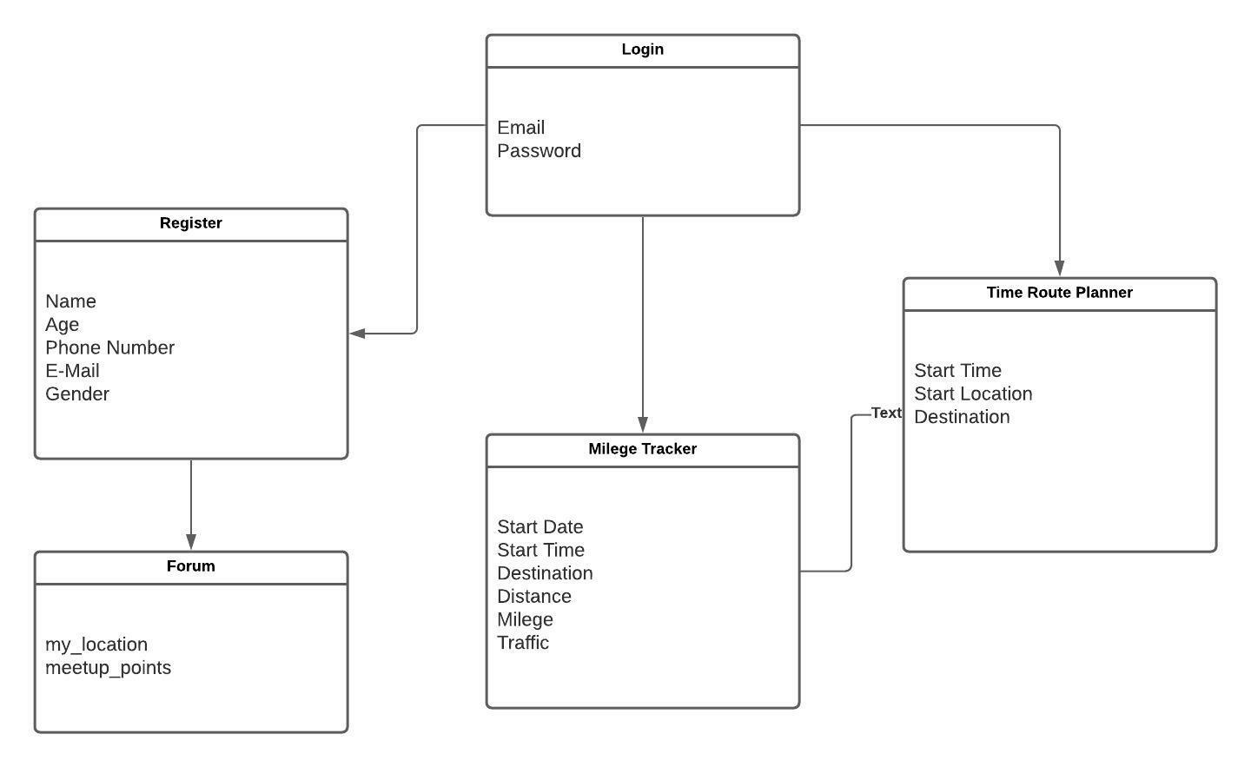

**Fig 3.1.1 ER Diagram**

**3.3 DATA FLOW DIAGRAM**

O level DFD Diagram

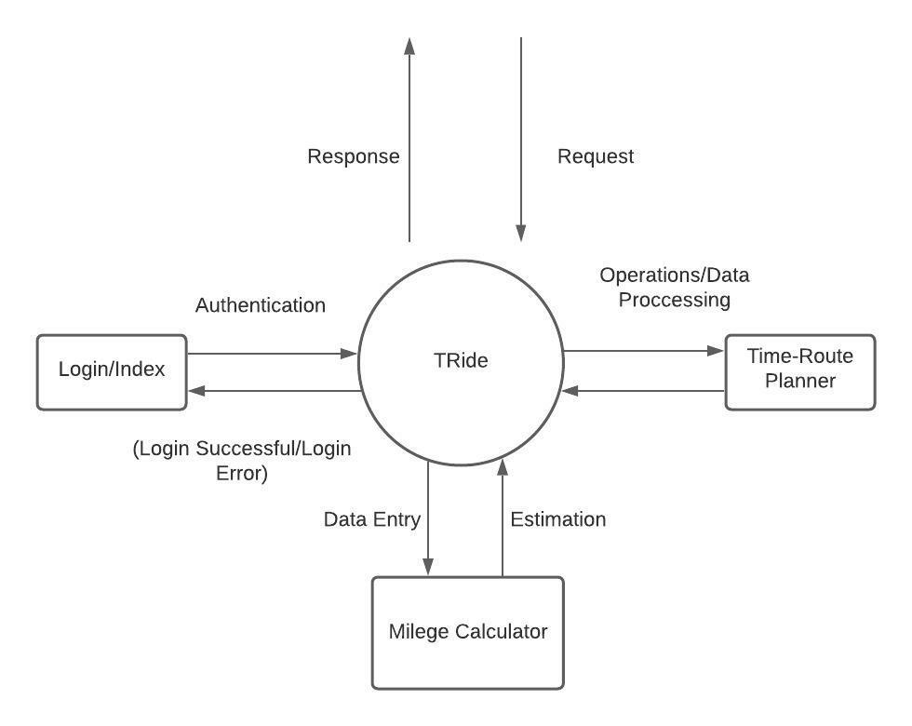

**Fig 3.3.1 DFD Diagram**

**3.4 USER INTERFACE DESIGN**

System design involves the transformation of the user implementation model into software design. The design specification of the proposed system consists of the following:

1. Database scheme
2. Structure charts
3. Pseudo codes for the modules in structure charts

**3.5 FLOW CHART**

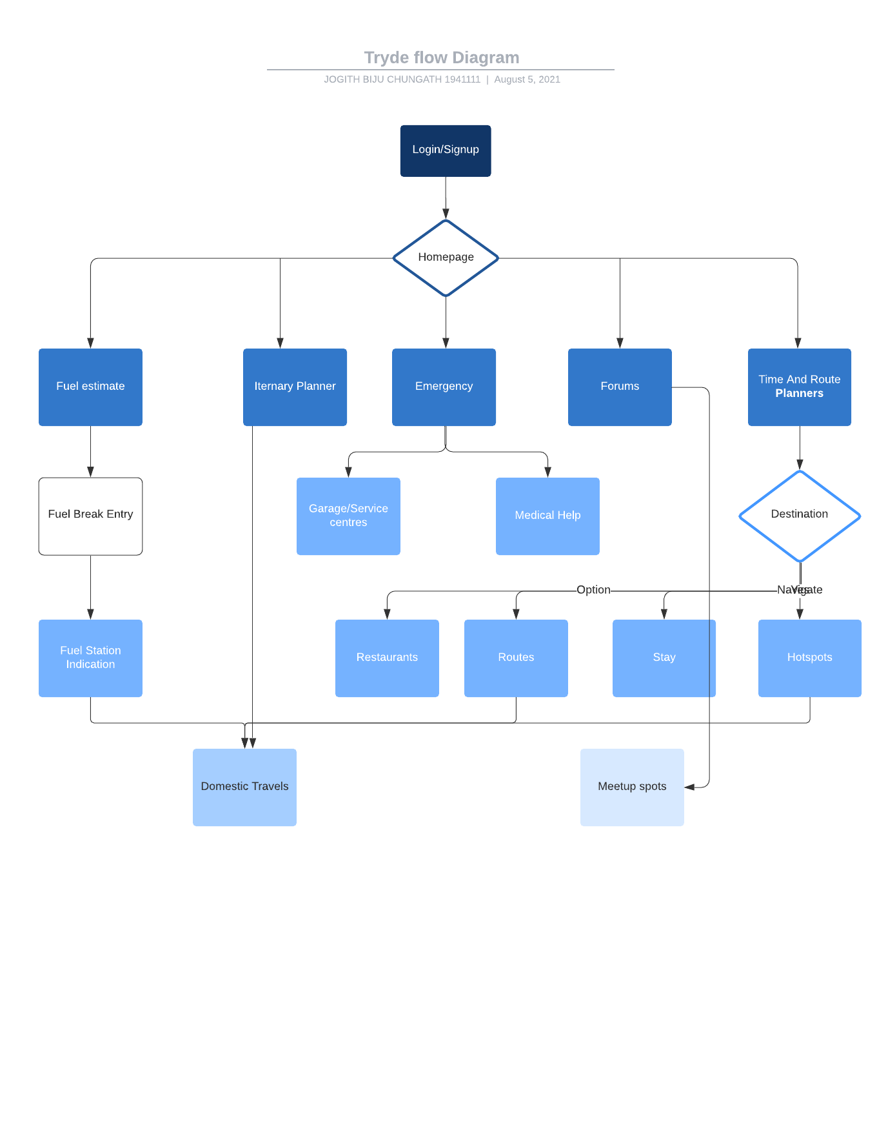

**Fig 3.5.1 Flow Chart**

**3.6 Reports Generated**

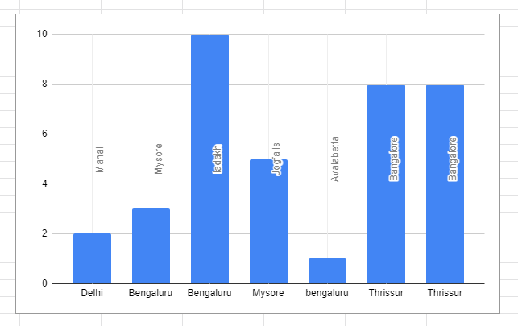

**Fig 3.6.1 Bar Chart Reports Generated**

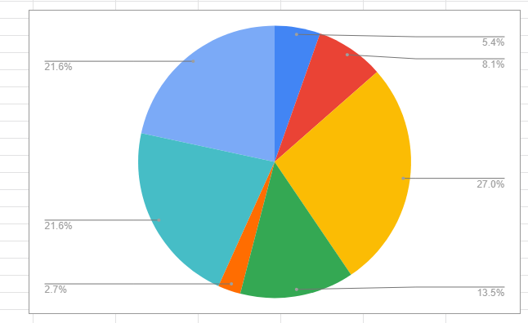

**Fig 3.6.2 Pie Chart Reports Generated**

**4. IMPLEMENTATION**

**4.1 SOURCE CODE**

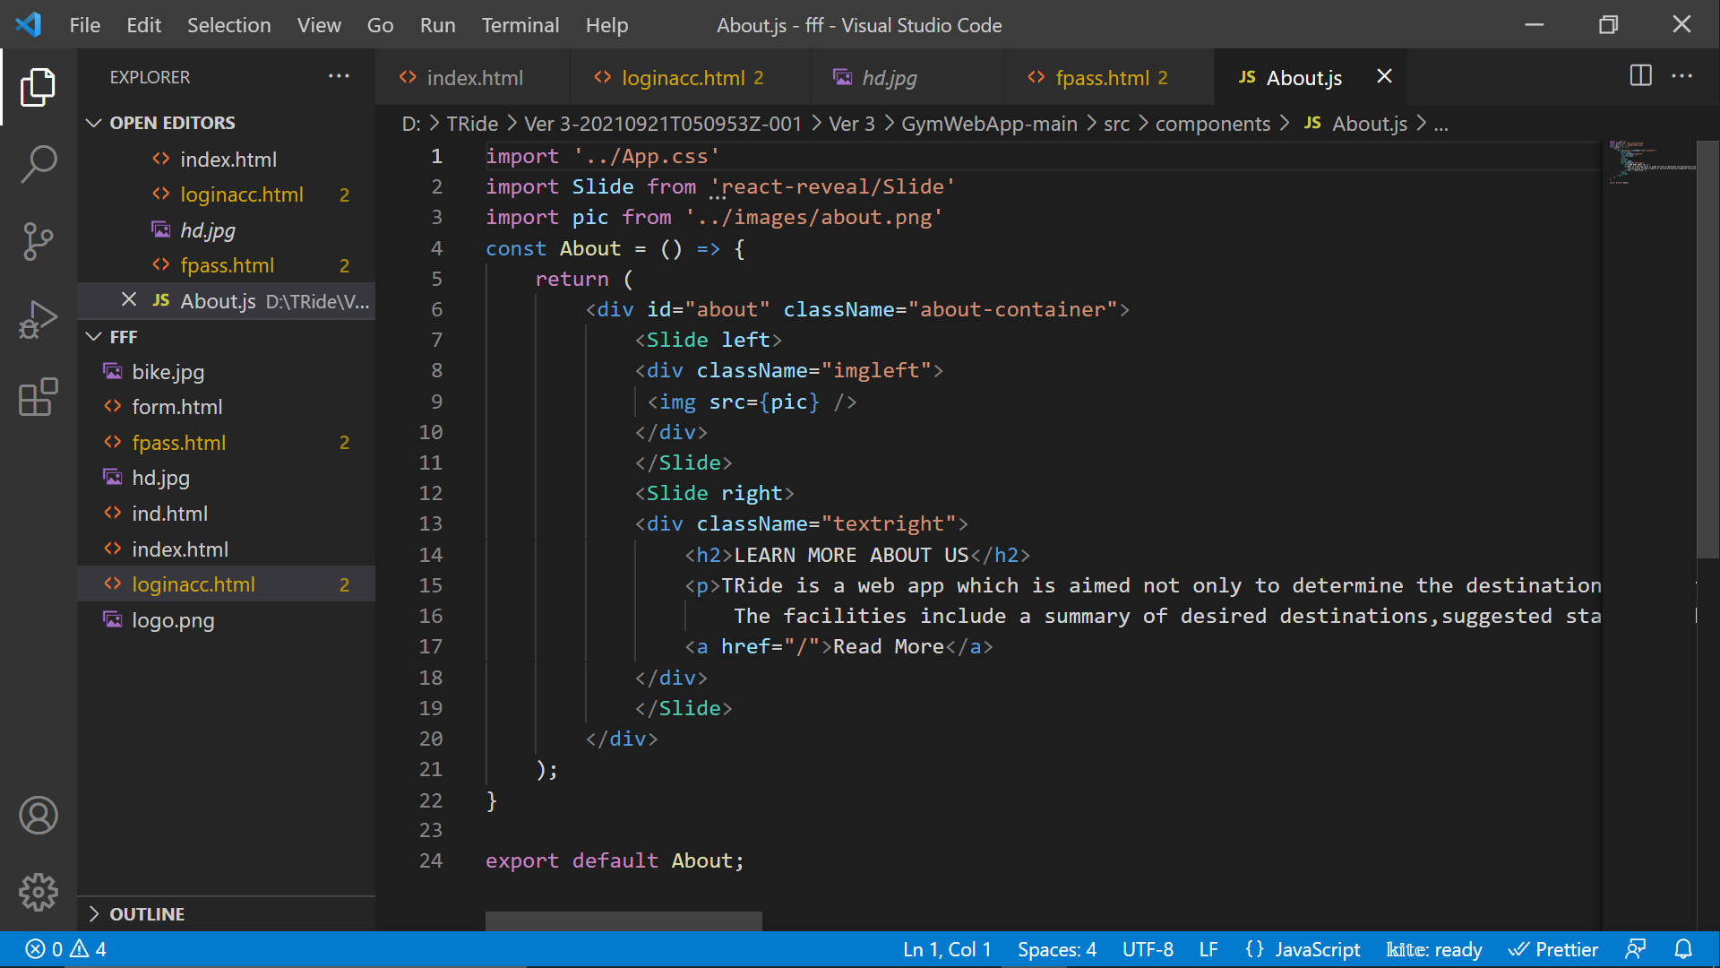

**Fig 4.1.1 Home Screen**

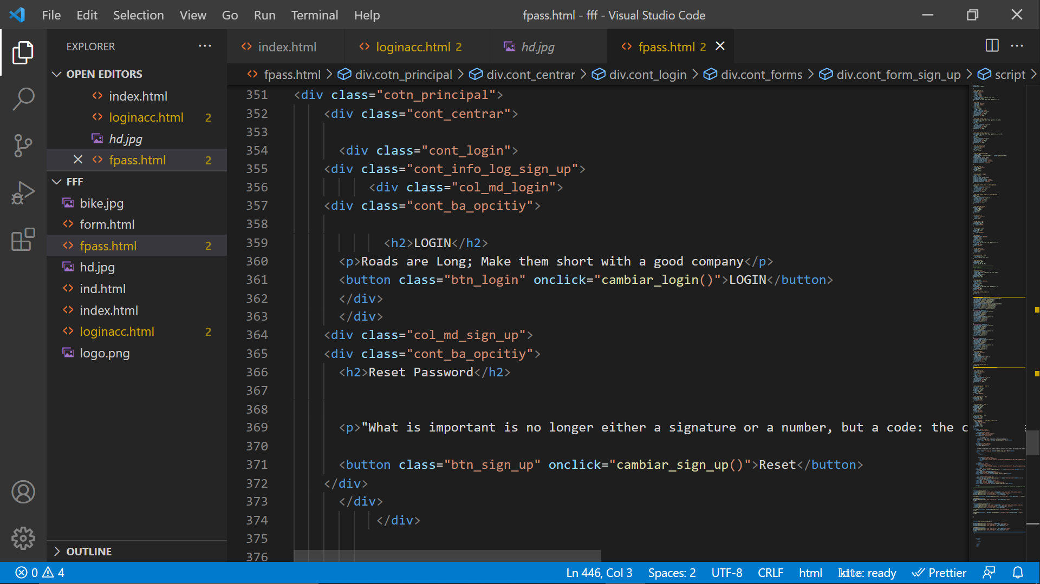

**Fig 4.1.2 Login**

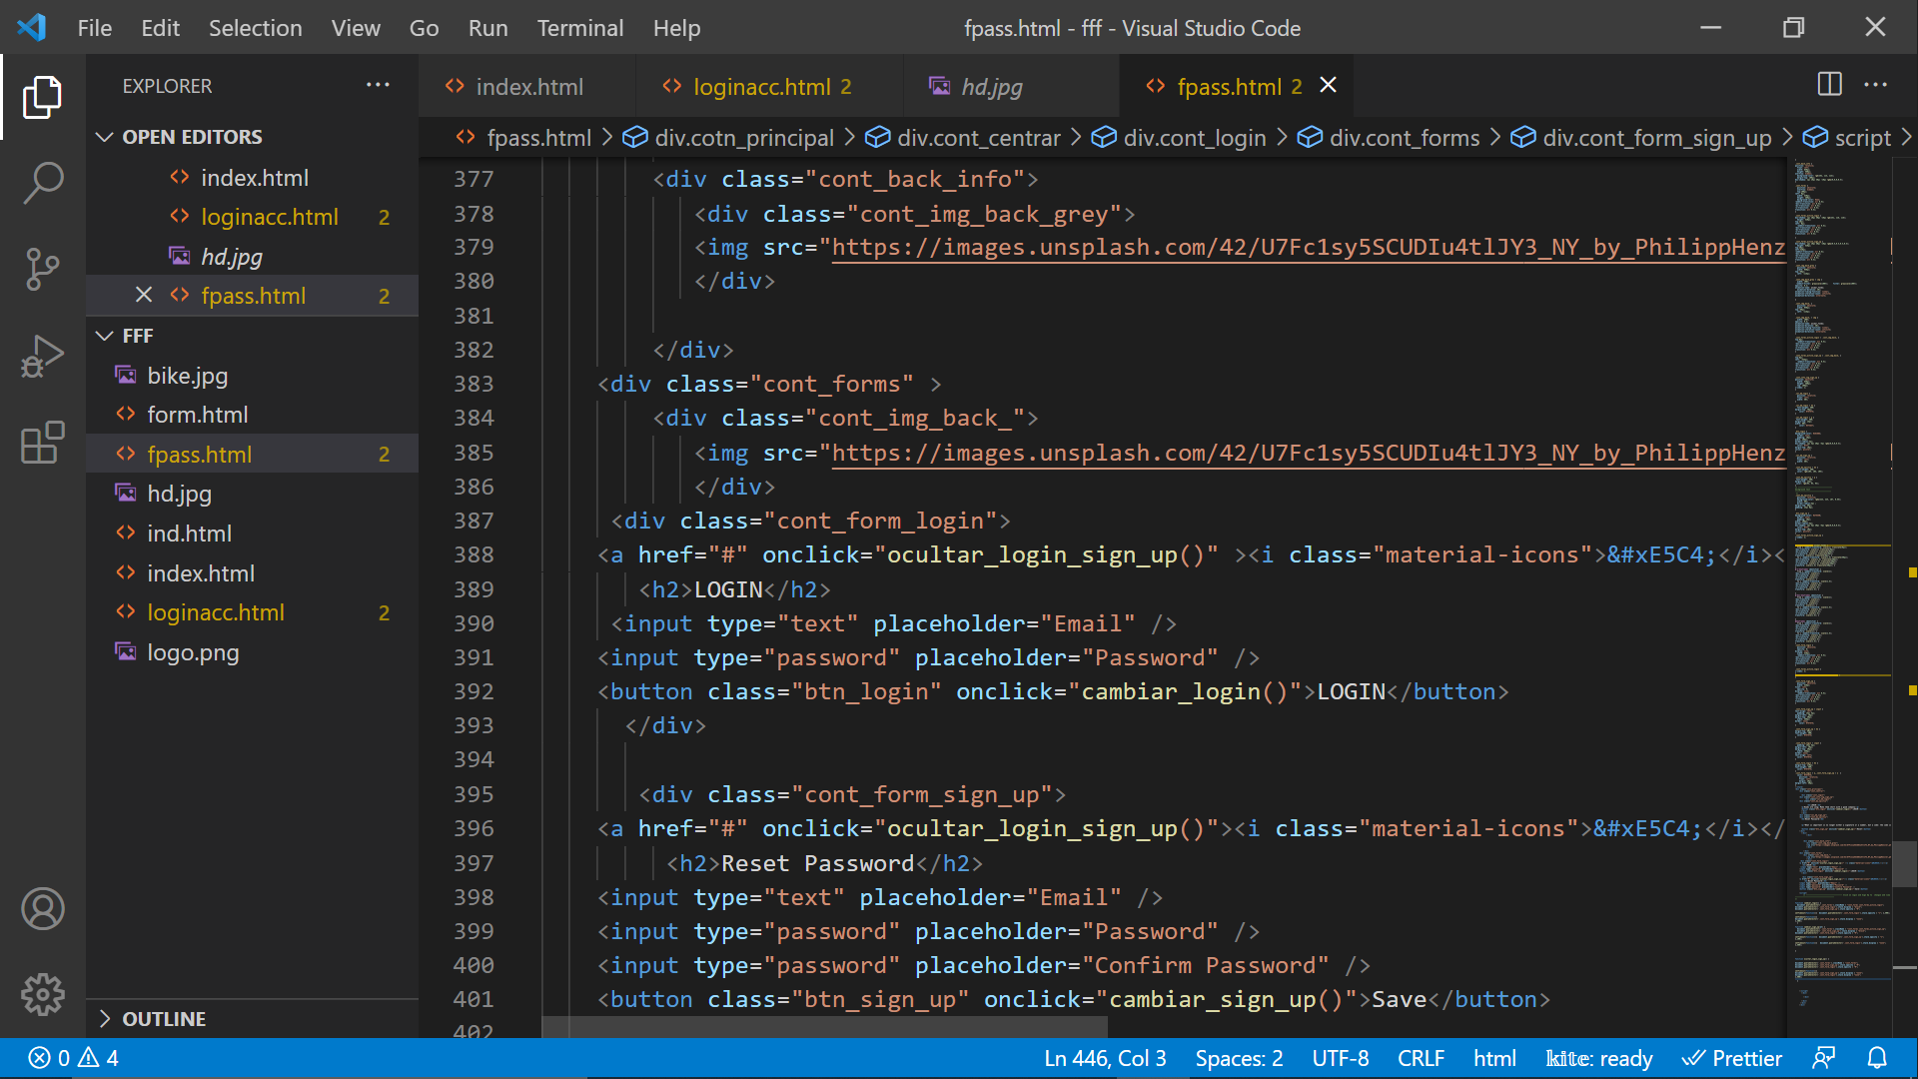

**Fig 4.1.3 New User**

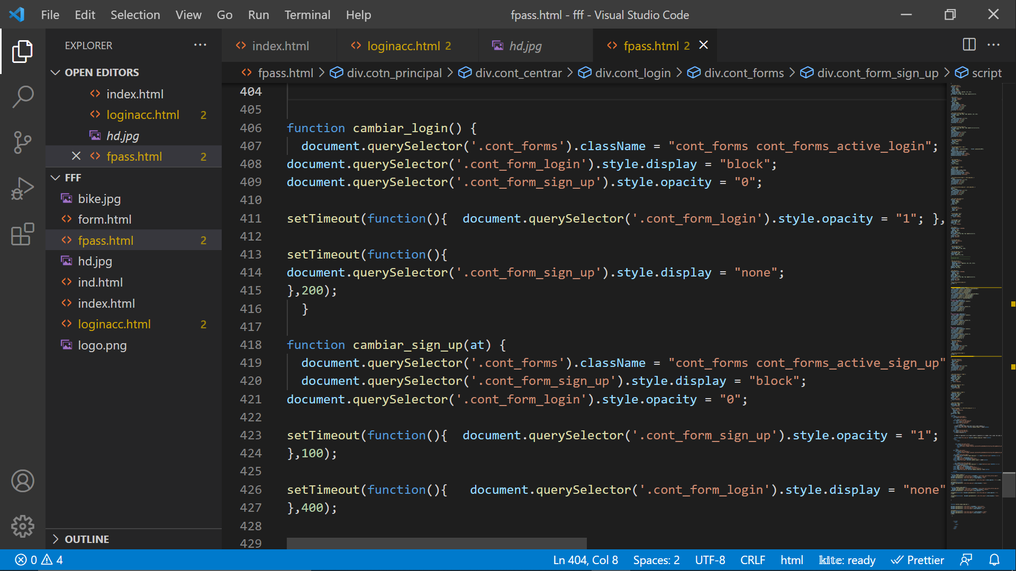

**Fig 4.1.4 Signup**

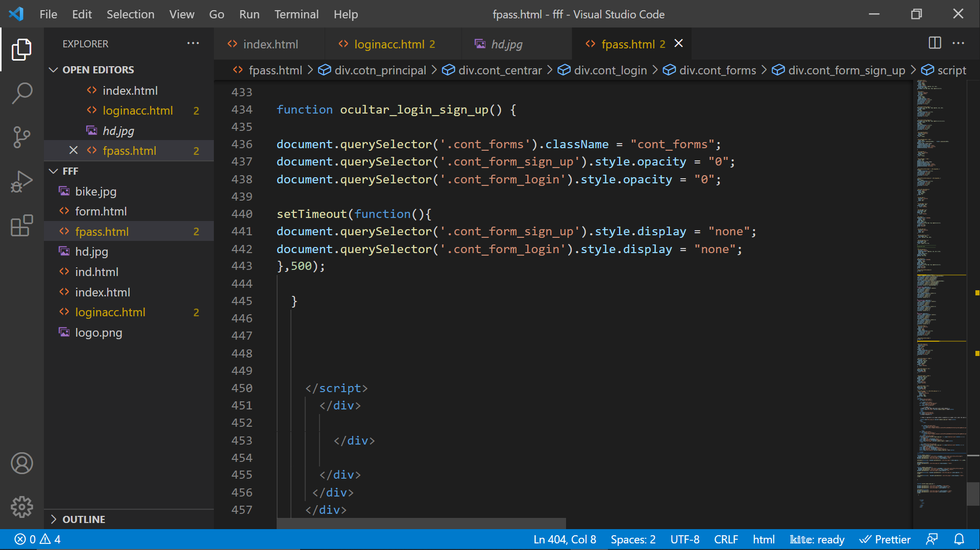

**Fig 4.1.5 Forgot password**

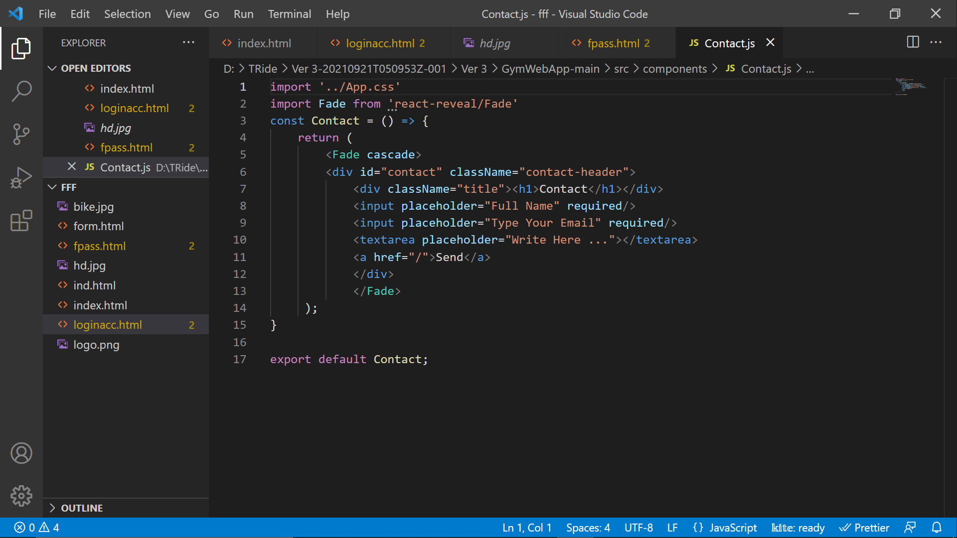

**Fig 4.1.6 Contact Us**

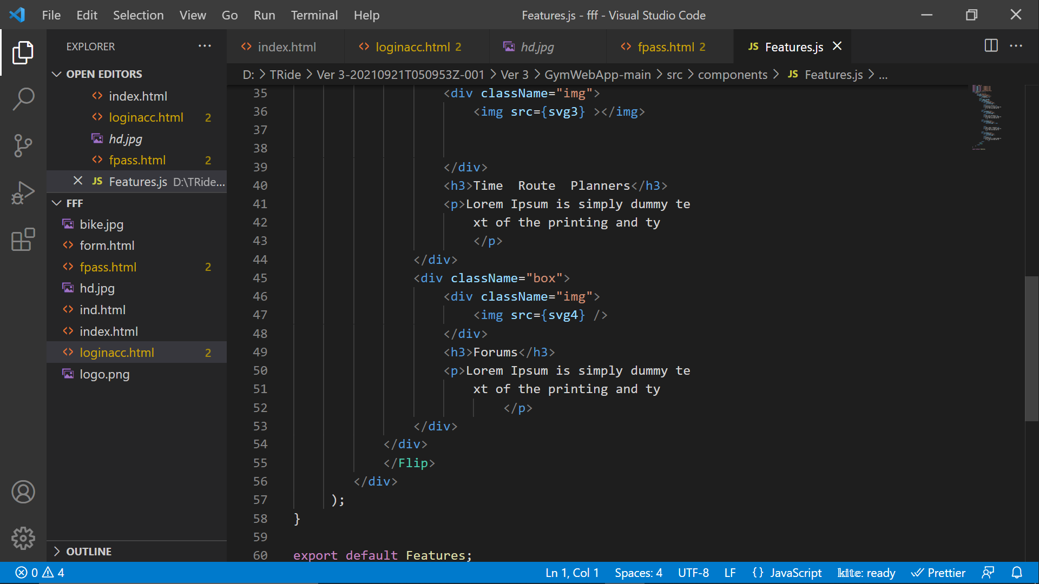

**Fig 4.1.7 Features**

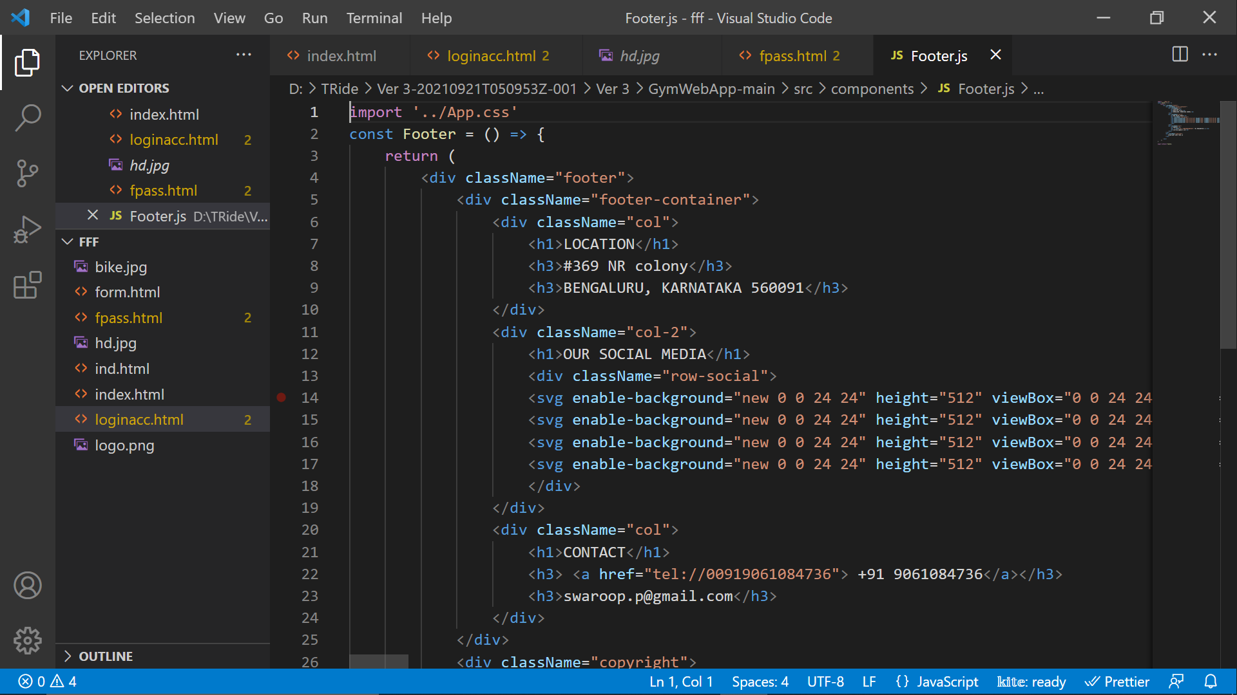

**Fig 4.1.8 Footer**

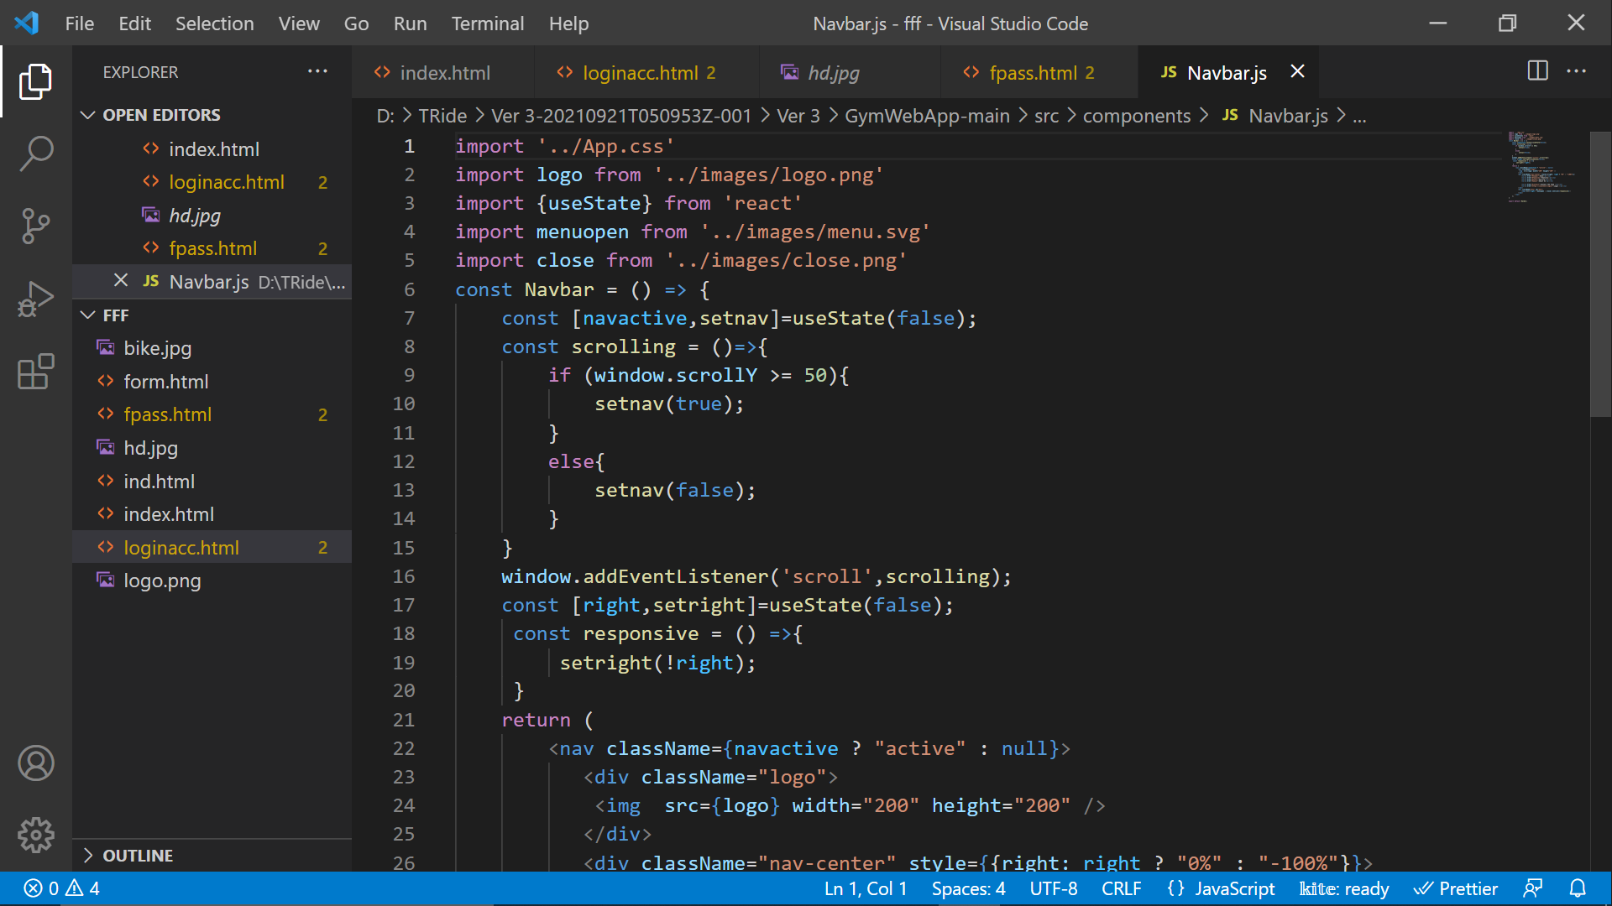

**Fig 4.1.9 Navigation Bar**

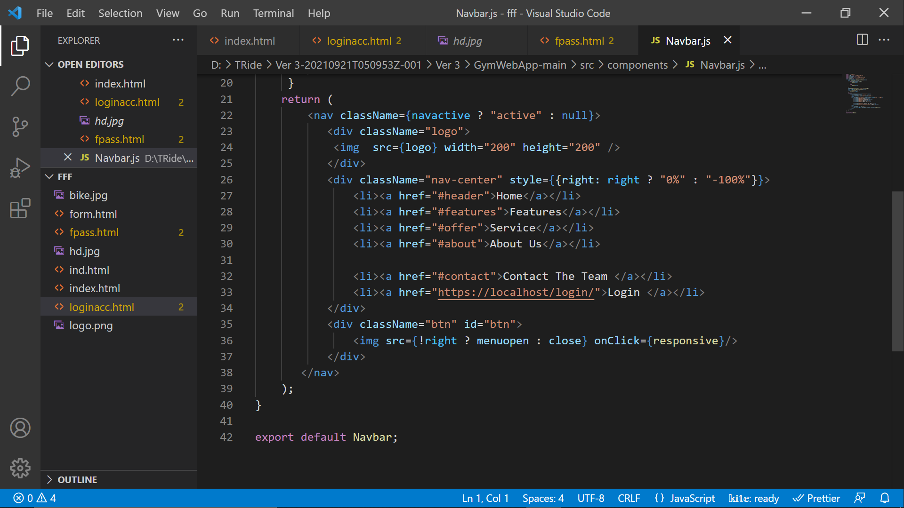

**Fig 4.1.10 Navigation bar Options**

**4.2  SCREENSHOTS**



**Fig4.2.1 Home page**

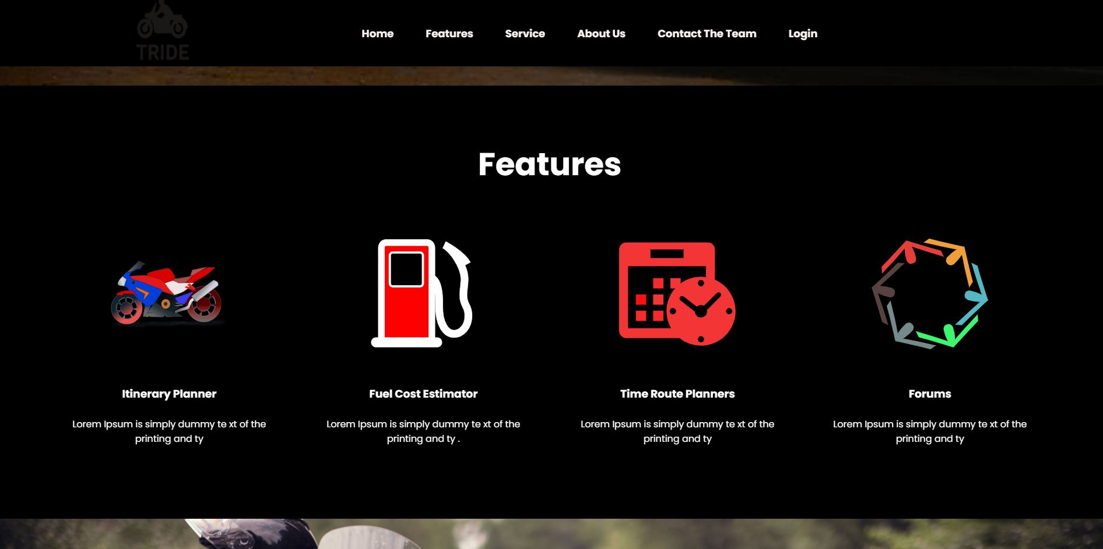

**Fig4.2.2 Features Page**

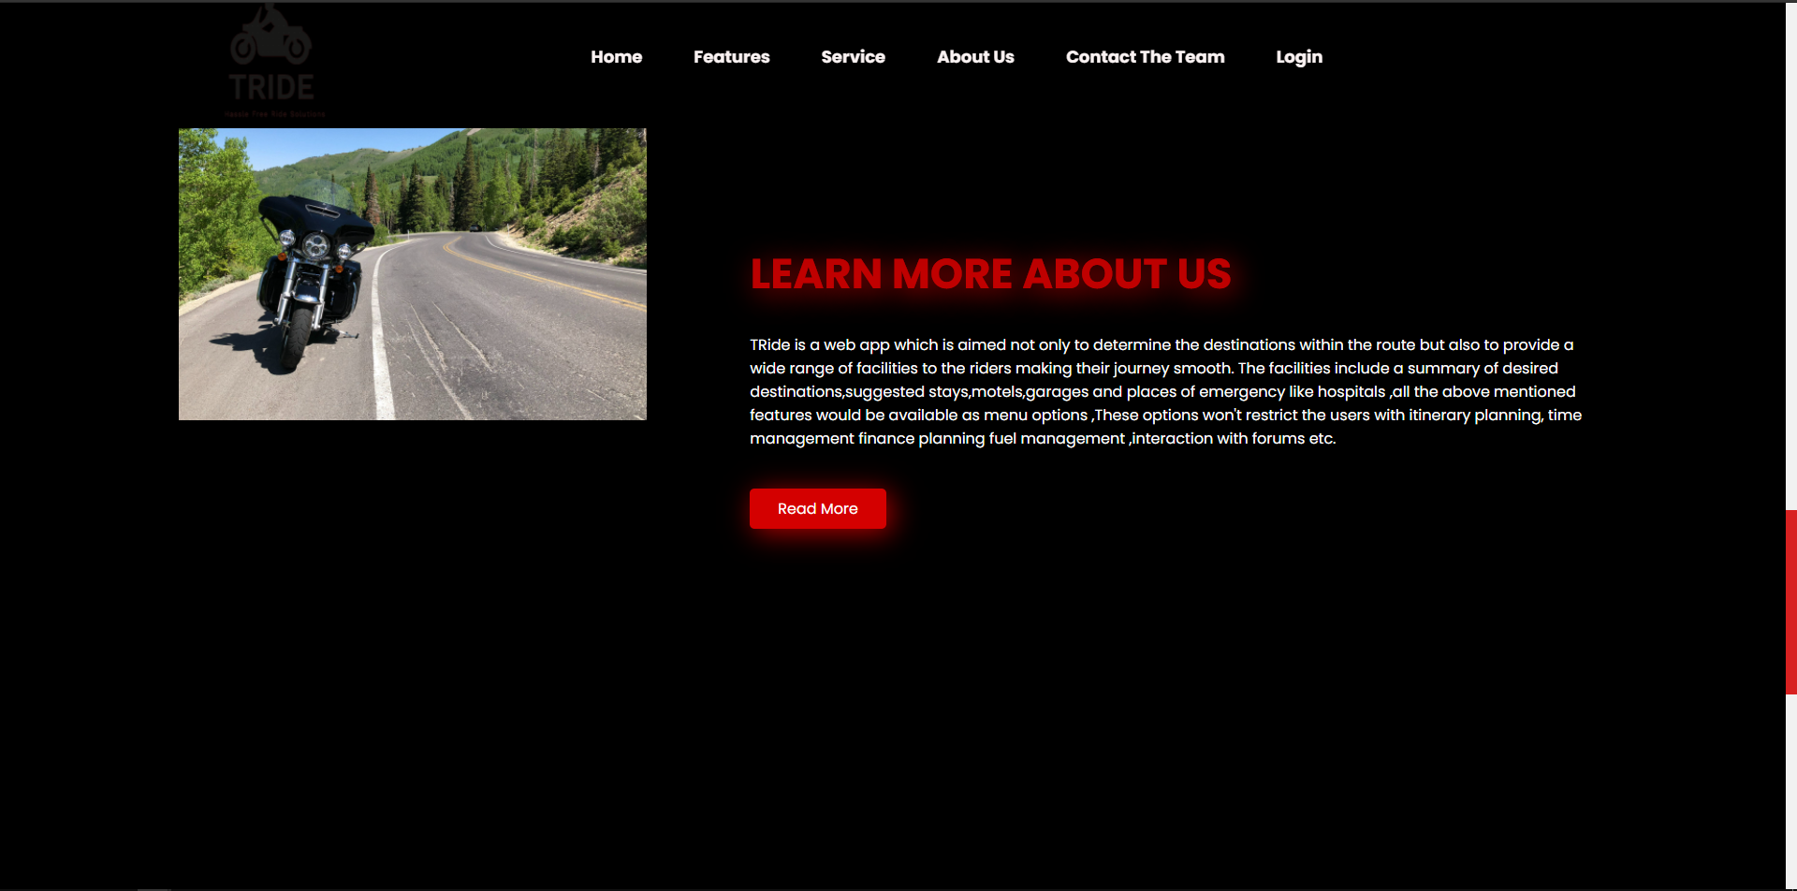

**Fig4.2.3 About Us**

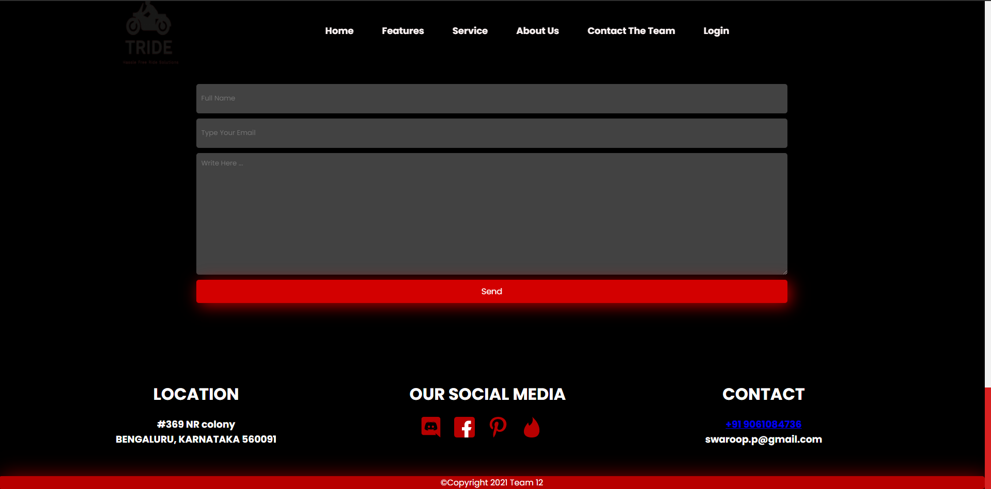

**Fig4.2.4 Contact Us**

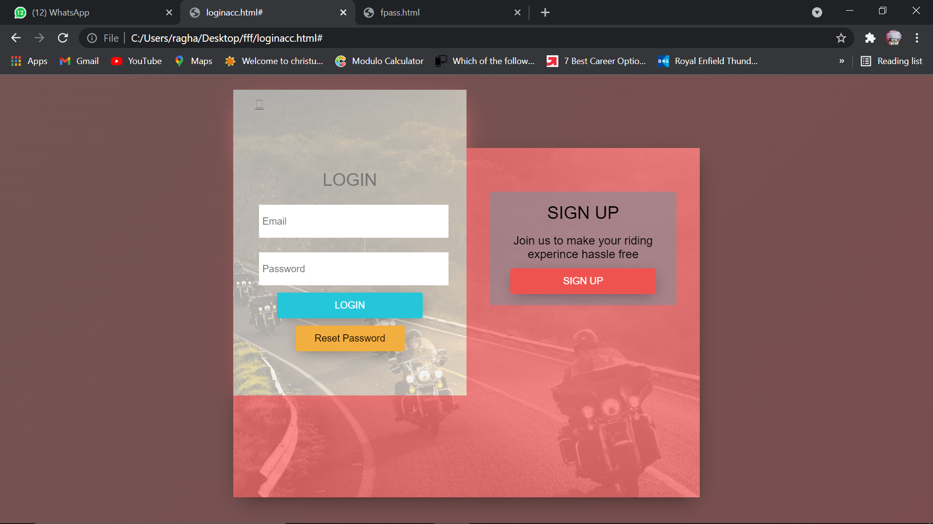

**Fig4.2.5 User Login**

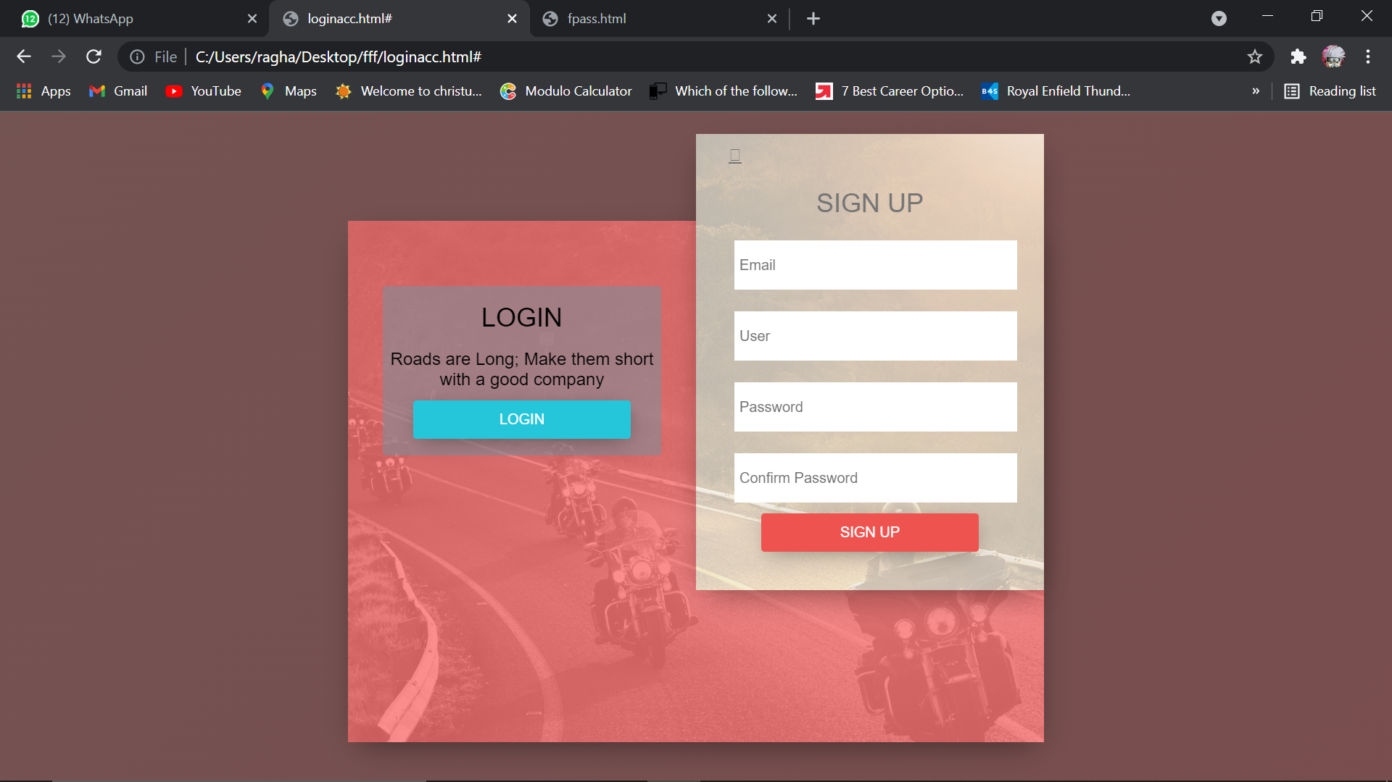

**Fig4.2.6 Sign up**

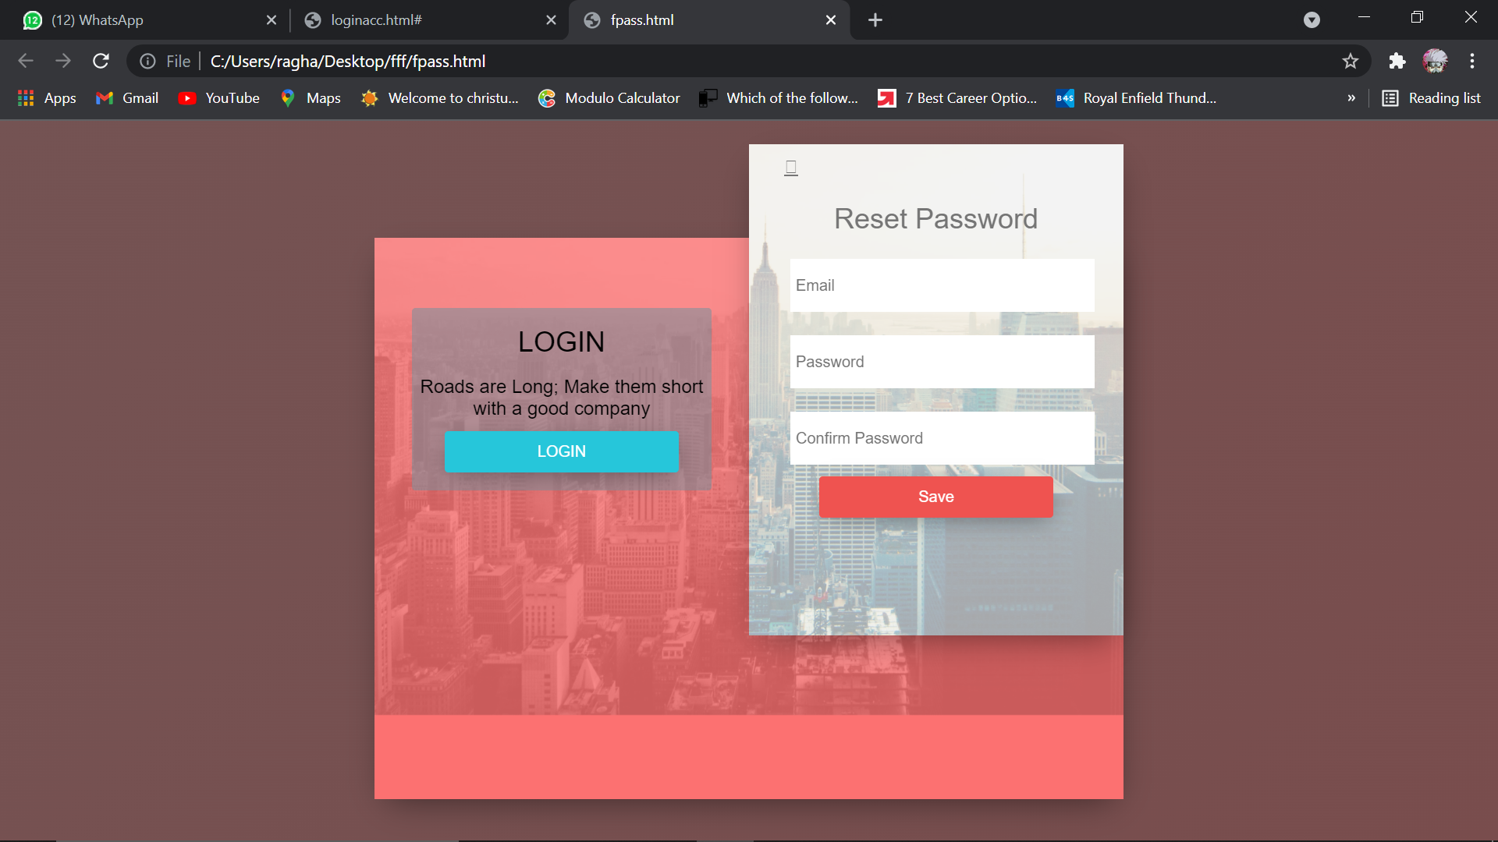

**Fig4.2.7 Reset Password**

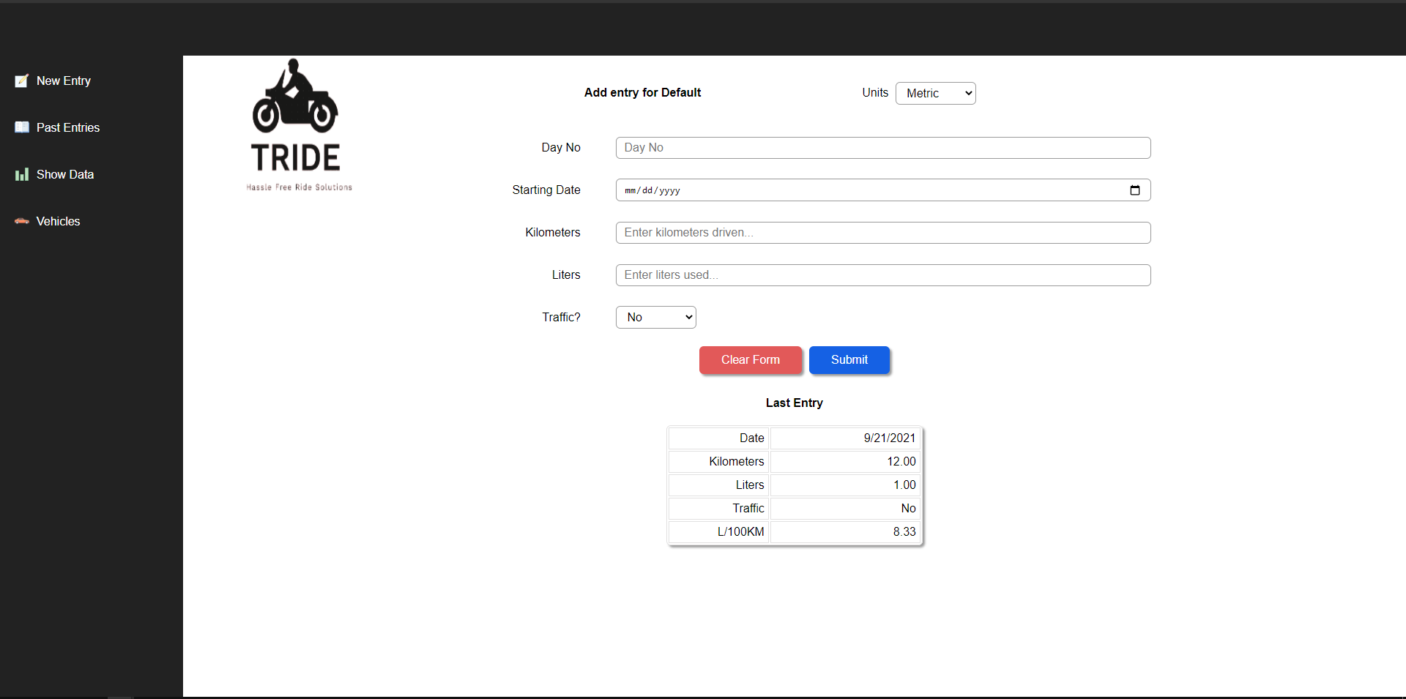

**Fig4.2.8 Fuel Calculator**

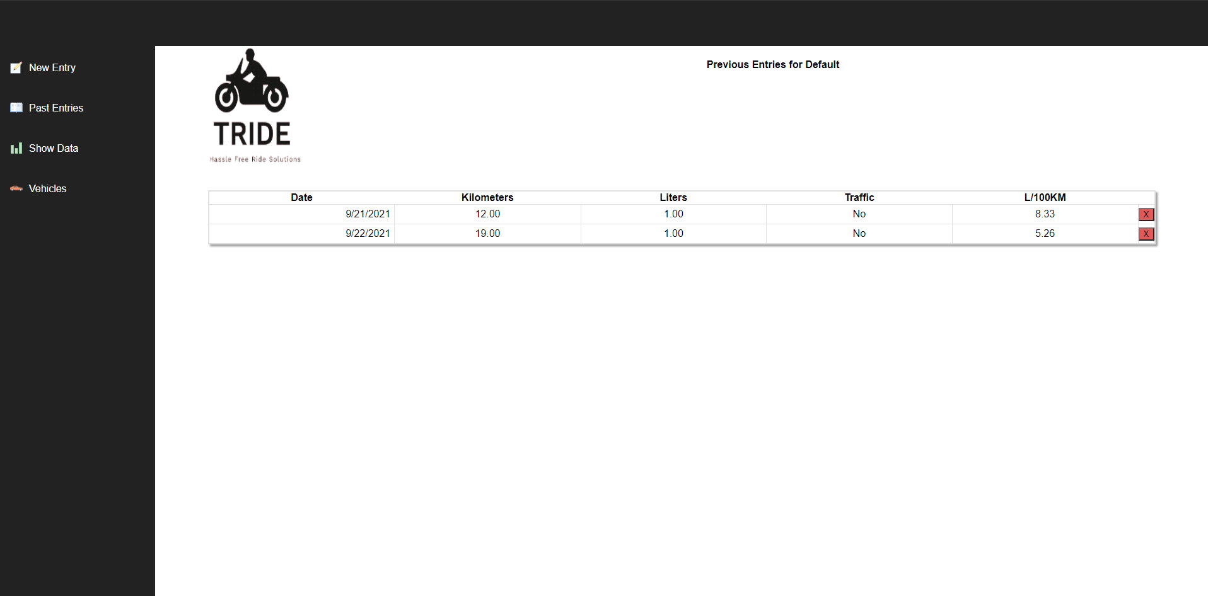

**Fig4.2.9 Past Entries**

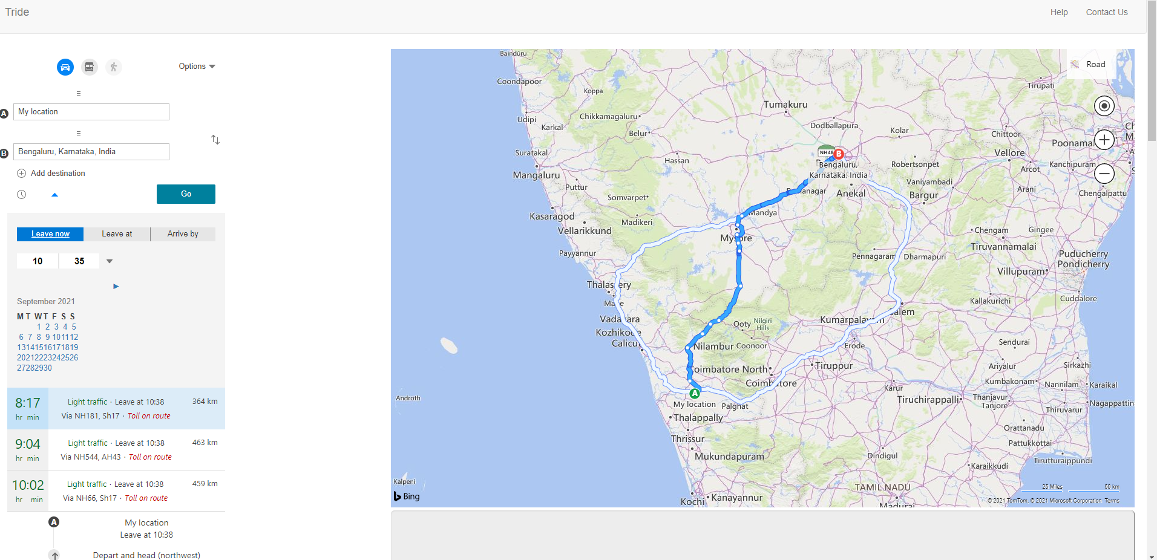

**Fig4.2.10 Map**

**5. TESTING**

Testing is the process of executing a program with the intent of finding errors. Although software testing is itself an expensive activity, launching software without it may lead to cost potentially much higher than that of testing, especially in systems where human safety is involved. Effective software testing will contribute to the delivery of higher quality software products, more satisfied users, and lower maintenance costs, more accurate and reliable results. Software testing is a. Call upon our vast experience in

**5.1 FUNCTIONAL TESTING**

It is very useful and convenient in support of functional testing. Although JMeter is known more as a performance testing tool, functional testing elements can be integrated within the Test Plan, which was originally designed to support load testing. Many other load-testing tools provide little or none of this feature, restricting themselves to performance-testing purposes. Besides integrating functional-testing elements along with load-testing elements in the Test Plan, you can also create a Test Plan that runs these exclusively. In other words, aside from creating a Load Test Plan, it also allows you to create a Functional Test Plan. This flexibility is certainly resource-efficient for the testing project.

### 5.2 REGRESSION TESTING

Regression testing can be described as “repeated functional testing”. It is used to make sure that a software’s functionality continues to work after parts of it have been modified with new code or configuration. For instance, when new features are built, regression testing ensures that old features of the software continue to work as intended.

Automated regression testing uses computer-based tools and techniques to test software that has been changed or updated. An automated process allows for the development of automated systems that re-run all regression tests at specified intervals, such as daily or weekly, and report any failure.

When regression testing is automated, you can quickly and reliably run through simple scenarios and check a variety of changes to get fast feedback. This, in turn, frees up time

### 

### 5.3 CROSS-BROWSER TESTING

Cross-browser testing ensures that your web application is performing as expected across different browsers, both on desktop and mobile.

This is important because browsers tend to be updated fairly frequently, meaning that by the time you are ready to deploy your application, it might not work as intended in your target browsers.

Not only that, users might be using the latest browser version but in an old operating system. Therefore, automating crow-browser testing ensures the continuous compatibility between your web application and the specified versions of operating systems, browsers and devices.

### 5.4 PERFORMANCE TESTING

Performance testing, such as stress and load testing, ensures that a web application can endure extended periods of activity or peak user loads. Reaching the necessary stress conditions or load level wouldn’t be feasible if done manually, therefore automation is key in proving that your application can perform in any situation.

**5.5 TEST CASES AND REPORT**

**5.5.1 TEST CASES**

* The system functional testing elements output the previous page.
* The output open-source should be correct – Every functionality of the system should be checked properly whether it gives the right result or not. Generally the test is performed with known results. If the output of the system is matched with that result the system is working fine.

**TEST CASES**

**Table 5.5.1 Test Case For User**

| **Serial No** | **Description** | **Expected     Result** | **Actual Result** | **Result** |
| --- | --- | --- | --- | --- |
| **1.** | This page contains 2 fields: username and password and a login button to submit the information. The user is entering the correct information. | The user home page should open after successful login. | The respective user home page is opened after successful login by the user. | Passed |
| **2.** | If either username or password is filled incorrectly or left blank. | An error message should be displayed and the user should be asked to fill in the information again. | When wrong information is entered by the user then an error message is displayed. | Passed |

**Table 5.5.2 Test Case For User Registration**

| **Serial No** | **Description** | **Expected     Result** | **Actual Result** | **Result** |
| --- | --- | --- | --- | --- |
| **1.** | User registration page 1 consists of detailed information about the User and a submit button to submit the information. Here use the changeover is entering the change over correct information. | After submitting information User registration page 2 should be displayed. | After submitting information User registration page 2 is displayed. | Passed |
| 2. | If the information entered by a user is incorrect or left somewhere blank. | An error message should be displayed and ask the user to fill in the information again. | An error message occurs if the information is incorrect or left blank. | Passed |

**Table 5.5.3 Test Case for Fuel Calculator**

| **Serial No** | **Description** | **Expected     Result** | **Actual Result** | **Result** |
| --- | --- | --- | --- | --- |
| **1.** | The user has to enter litres used and also if he/she has experienced any traffic.  The user has to enter the day number and kms planned to travel on that particular day. | After submitting the information the fuel calculator will show the results entered. | After submitting the information the fuel calculator will show the results entered. | Passed |
| 2. | If the information entered by a user is incorrect or left somewhere blank. | An error message should be displayed and ask the user to fill in the information again. | An error message occurs if the information is incorrect or left blank. | Passed |

**Table 5.5.4 Test Case for Maps**

| **Serial No** | **Description** | **Expected     Result** | **Actual Result** | **Result** |
| --- | --- | --- | --- | --- |
| **1.** | User has to enter Start Location and Destination | After submitting the locations, the user will be able to see directions to their destination. | After submitting the locations, the user will be able to see directions to their destination. | Passed |
| 2. | If the information entered by a user is incorrect or left somewhere blank. | An error message should be displayed and ask the user to fill in the information again. | An error message occurs if the information is incorrect or left blank. | Passed |

**Table 5.5.5 Test Case for Trip Diary**

| **Serial No** | **Description** | **Expected     Result** | **Actual Result** | **Result** |
| --- | --- | --- | --- | --- |
| **1.** | User has to enter Start Location, Destination, Estimated Time and Ride type | Users will be taken to the maps, from there they can plan more about their trips | Users will be taken to the maps, from there they can plan their trips well. | Passed |
| 2. | If the information entered by a user is incorrect or left somewhere blank. | An error message occurs if the information is incorrect or left blank. | An error message occurs if the information is incorrect or left blank. | Passed |

**5.6 IMPLEMENTATION**

Implementation is the stage in the project where the theoretical design is turned into the working system and is giving confidence to the new system for the users i.e. will work efficiently and effectively. It involves careful planning, investigation of the current system and its constraints on implementation, design of methods to achieve the change over, and evaluation of change over methods. A part of planning the major task of preparing the implementation is the education of users. The more complex system is implemented, the more involved will be the system analysis and design effort required just for implementation. An implementation coordinating committee based on policies of individual organizations has been appointed. The implementation process begins with preparing a plan for the implementation ofLeveled the system. According to this plan, the activities are to be carried out; discussions regarding the equipment have to be acquired to implement the new system.

Implementation is the final and important phase. The most critical stage is in achieving a successful new system and in giving the users confidence that the new system will work and be effective. The system can be implemented only after thorough testing is done and if it is found to work according to the specification. This method also offers the greatest security since the old system can take over if errors are found or the inability to handle certain types of transactions while using the new system.

At the beginning of the development phase, a preliminary implementation plan is created to schedule and manage the many different activities that must be integrated into the plan. The implementation plan is updated throughout the Development phase, culminating in a changeover plan for the operation phase.  The major elements of the implementation plan are the test plan, training plan, equipment installation plan, and conversion plan.

There are three types of implementation:

1. Implementation of a computer system to replace a manual system.
2. Implementation of a new computer system to replace an existing system.
3. Implementation of a modified application to replace an existing one, using the same computer.

Successful implementation may not guarantee improvement in the organization using the new system, but improper installation will prevent it. It has been observed that even the best system cannot show a good result if the analysts managing the implementation do not attend to every important detail. This is an area where the systems analysts need to work with utmost care.

After the system is implemented and conversion is complete, a review should be conducted to determine whether the system is meeting expectations and where improvements are needed. A post-implementation review measures the system's performance predefined requirement. It determines how well the system continues to meet the performance specifications.

**6. CONCLUSION**

    Our application ‘Tride’, a riding assistant built for bikers makes use of several advanced features: the Logged in user can access all the features Such as fuel Mileage, Trip Planner, and Split which helps the riders to reach their destined place.

6.1 **Design and Implementation Issues**

Software design and implementation is the stage in the software engineering process at which an executable software system is developed. Software design and implementation activities are invariably inter-leaved. – Software design is a creative activity in which you identify software components and their relationships, based on a customer’s requirements. – Implementation is the process of realizing the design as a program.

6.1.1 **Design Issues**

There can be a discrepancy between project design and external factors that impact and should dictate the project’s design (determining whether to use a formal approach etc). Project design should be based on its aims and objectives and will be impacted by the target group, available resources, project timeframe and setting in which the program is implemented.

Projects also need to determine whether they will take a formal or informal approach to their work. The evidence isn’t consistent as to which has greater success, and selection should be based on the ability to provide training, supervise the program and the needs of the target group.

**6.2 Advantages and Limitations**

**6.2.1 Proposed System**

One must know what the problem is before it can be solved. The basis for the trip planning assistant is to make the journey a pleasurable one and save timing.

A trip-planning assistant, helps users to plan trips more efficiently rather than consulting a travel advisor or trip agency who wants to buy any product of their need and has to contact different agencies, before deciding upon a particular trip plan that best suits his needs, requirements, and satisfaction. Moreover, most of the work involved in this development process has to be done manually which is very time-consuming and cumbersome, and also reduces efficiency, accuracy.

To know the facts and understanding of the problem in detail, System Analysis is carried out. It is the process of studying the business processes and procedures, generally referred to as business systems, to see how they can operate and whether improvement is needed.

**6.2.2 Benefits of Proposed system**

1) Immediate retrieval of information

The main objective of the new system is to provide for quick and efficient retrieval of information. Any type of information would be available to the user whenever he requires it. The facility would be provided for online queries to cut down on the response time greatly.

2)Immediate storage of information

In the proposed system, it will be easy to store information at any given time at the correct places. The location of storage would be easily available and the user will face no difficulty.

3) Prompt updating of information

In the proposed system, the information will always remain up to date as the updating will be prompt and without any effort. This factor will be of great importance in the proposed system as it determines the integrity of the information stored.

4) Fast computation of information

The computation of information will be quite fast in the proposed system. Not only mathematical calculations but also logical comparisons will be quick in the new system.

5) Planned approach toward working

The working in the service centre information system will be well planned and organized. The data will be stored properly in the data store, which will help in the retrieval of information as well as in its storage.

6) Generation of managerial and strategic reports

The new system would provide for regular generation of reports, which would help the user in decision-making work and in controlling the overall working of the organization. The generation of these reports would be possible only if the system is organized such that retrieval of information can be made on conditions.

7) Accuracy

The level of accuracy in the new proposed system would be higher. All operations and computations would be done correctly and this will ensure that whatever information is coming from the centre log–in a user-friendly front-end, is accurate.

8) Reliability

The reliability of the proposed system would be high due to the above-stated reasons. The reason for the increased reliability of the system is that now there would be proper storage of information, its maintenance would be well managed and retrieval would be possible in the desired manner.

9) Non Redundant Information

In the new system, utmost care would be taken that no information is repeated, any usage of storage or otherwise. This would assure economic usage of storage or space and consistency in the data stored. This will also help make those changes easily as the change would have to be made only at that very place and nowhere else.

Although we have tried to do our best and try to do all the things that are possible in an

trip planning assistance, but still the system contains some of the limitations.

The reason for these limitations is the time constraints. Time is the major problem. We

had to deliver the project in a particular period. That’s why we had to leave. Some of the topics that we wanted to cover. This project does not give information about the places to be visited present within the trip planned by the user.

**6.3 Future Scope**

A trip-planning assistant, helps users to plan trips more efficiently rather than consulting a travel advisor or trip agency who wants to buy any product of their need and has to contact different agencies, before deciding upon a particular trip plan that best suits his needs, requirements, and satisfaction. Moreover, most of the work involved in this development process has to be done manually which is very time-consuming and cumbersome, and also reduces efficiency, accuracy.

**REFERENCES**

[1]. Shea, Dave and Holzschlag, Molly M. The Zen of CSS Design: Visual Beauty for the Web, Peachpit Press, 2004.

[2]. Schmitt, Christopher. CSS Cookbook, O'Reilly & Associates, 2006.

[3]. Schmitt, Christopher et al. Professional CSS, Wrox, 2005.

[4]. Sullivan, Stephanie, and Rewis, Greg. Mastering CSS with Dreamweaver CS3, New Riders Press, 2008.

[5]. Weakley, Russ. Teach Yourself CSS in 10 Minutes, Sams, 2005.

[6]. Wroblewski, Luke. Mobile First, A Book Apart, 2011.

**BIBLIOGRAPHY**

This document contains provisions that, through reference in this text, constitute provisions of the present document.

1. Web-Technologies Black Book
2. Keeves PHP- MYSQL
3. Wrox Press – Beginning PHP5
4. Online at [www.w3schools.org](http://www.w3schools.org)
5. Murach’s-PHP/MYSQL
6. https://animista.net/
7. https://csslayout.io/
8. https://www.shapedivider.app/
9. https://autoprefixer.github.io/
10. http://ami.responsivedesign.is/
11. https://caniuse.com/
12. https://fonts.google.com/
13. https://www.flaticon.com/
14. https://undraw.co/search

**USER MANUAL**

**DEFINITIONS**

1. BROWSER: A software application used to locate and display web pages.
2. DATABASE: A database that stores data. It is a collection of interrelated data that contains information relevant to the enterprise.
3. DBMS: A collection of a computer program that allows storage, modification, extraction of information from the database.
4. HOMEPAGE: The first page when you go to a worldwide website on the internet.
5. HTML: It is a computer language specifying the content & formats of a web document. It allows additional text to include codes that define fonts, layouts, graphics & hypertext.
6. INTERNET: Worldwide networks of computers from where anyone can take the information.
7. MYSQL: Most widely used query language for creating the database.
8. PHP: It is called Hypertext Preprocessor.
9. SQL: It is a standard interactive & programming language for getting information & updating databases empties user-friendly front-end.
10. WEBPAGE: pages of information placed on the network that may contain text, graphics, images, moving pictures, sound files & other types of electronic information.
11. WEBSITE: Collection of files called webpage, which can contain text & images.